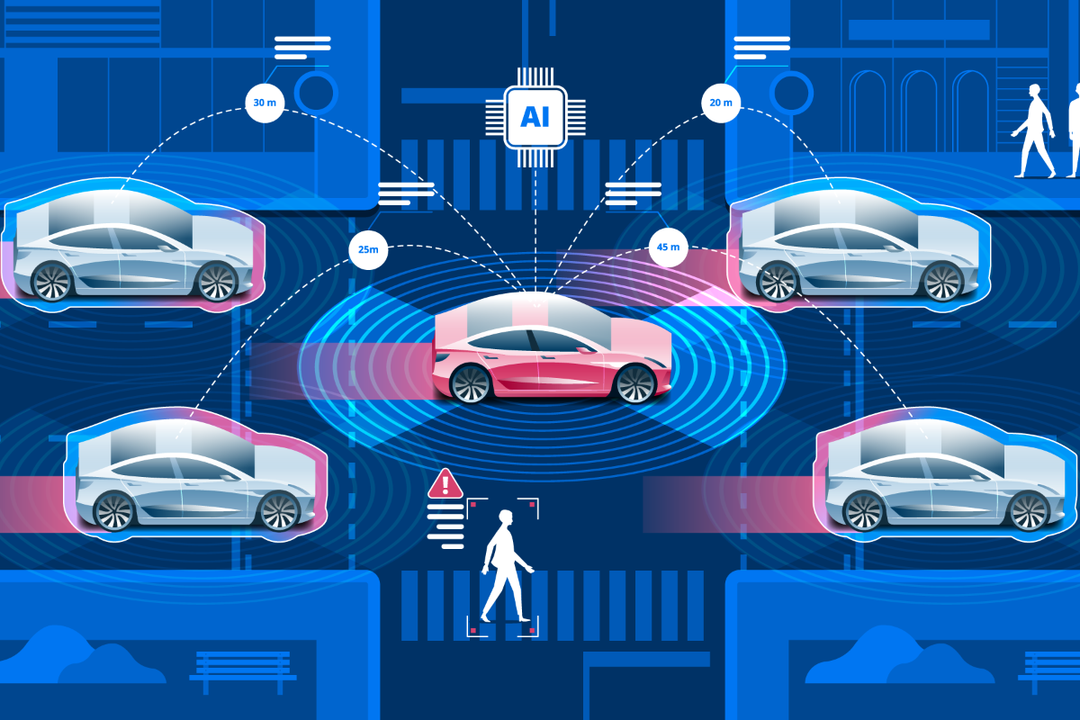  Perceptions of Autonomous Vehicles in Arlington County, VA  A local perspective | Daniel Clark  With initial research contributions from Brandon McCord, James Mills & Rahel Tekle


July 2020

Daniel Clark
dclark18@vt.edu

Abstract
Autonomous vehicles (AVs), sometimes referred to as self-driving or driverless vehicles, are computer and network-controlled vehicles that are capable of sensing their environment and navigating different traffic conditions without human input. How does the public feel about this revolutionary technology? What excites people and what concerns them about AVs?
Varying degrees of vehicle automation technology exist today. Transportation and technology companies have begun testing fully autonomous vehicles, which are programmed to handle all steering, braking, and accelerating decisions based on live traffic and road conditions. It is anticipated that AVs could bring many benefits to communities, namely expanding mobility options, however there are also concerns about their impact. Understanding public perceptions is a key tenet of AV adoption and is crucial for policy makers and the companies which develop AVs as they encourage people to embrace this technology.
This report contributes a local understanding of AV perceptions in Arlington, VA, a suburb of Washington, D.C. To our knowledge, no study has yet conducted a local survey in the region about perceptions of AVs. Our literature review gathers prior perception surveys about AVs which have been conducted mainly at the national and international level. There are limited regional-level studies on this topic. Previous research has identified differences in perceptions by gender and age and have found that men are more enthusiastic and excited about using this technology, while women are more apprehensive. Generational attitudes vary too, with younger people more likely to adopt and older people more hesitant to do so.
Our analysis focuses on gender and age differences in our study sample in order to test the findings in the literature we reviewed. We administered an online survey to 443 individuals in February and March of 2019. Our sample population has an awareness of, and are generally enthusiastic about AVs, although respondents lacked personal or anecdotal experience with the technology. Our study found key differences in responses by gender, notably how men and women self-report their own understanding of AV development and testing.

Preface
This report is an outgrowth of a studio project led by Dr. Elizabeth Morton conducted during the 2018-2019 academic year at Virginia Tech. Completed within the Masters in Urban and Regional Planning program, the year-long course examined autonomous vehicles and their potential impacts in Arlington County, Virginia.

Keywords:
Autonomous vehicles, Self-driving, Driverless vehicles, Perceptions, Public opinion, Safety

Table of Contents
Abstract 1
Preface 1
Introduction 3
Survey Methodology & Collection 4
Limitations 5
Existing Research 6
Arlington County Survey Findings 9
Awareness 9
Perceived benefits and concerns 11
Analysis by gender 13
Analysis by age 14
Summary 14
Recommendations 15
Appendix A: Survey of Perceptions of Autonomous Vehicles (AVs) 16
Appendix B: Statistical analysis in STATA 24
Gender 24
Age 27

Introduction
Autonomous vehicles (AVs), known also as self-driving or driverless vehicles, are computer and network-controlled vehicles that are capable of sensing their environment and navigating different traffic conditions without human input.[] There is a spectrum of 5 levels of vehicle automation. Level 0 refers to “no automation”, where humans are in full control of the vehicle. Level 5 refers to “full automation”, where an on-board computer controls all decision-making.[] AVs represent one of the greatest technological advances in transportation since the advent of the internal combustion engine.[]
AV testing is currently happening on a commercial scale worldwide.[] Many large technology and transportation companies, such as Google, Ford, Waymo, and Toyota (among many others) are actively competing to advance this technology. AVs will likely fundamentally change our relationship with transportation and influence how everyday travel decisions are made. Much improved vehicle safety, greater fuel efficiency, increased access and reduced user stress are among the top potential benefits experts anticipate.[] [] [] Widespread adoption will likely introduce many serious challenges too. Potential increases in vehicle miles traveled, uncertain liability concerns, lost jobs to automation and high initial user costs are a few such hurdles.[]
It is crucial to understand what people think about this new technology that has such potential to revolutionize the way we get around. News of a self-driving Uber that struck and killed a woman in 2018 led to international media attention and questions about the safety and the public’s willingness to accept this technology.[] Understandable hesitations about the reliability of and confidence in on-board vehicle computers has led some to express fear, anxiety, and hesitation about AVs.[] Evaluating and understanding public perceptions of AVs is crucial for long-term success of this technology.[] This report analyzes perceptions of AVs from people in Arlington County, VA, a jurisdiction within the Washington, D.C. Metro region.
Over the past few years, a number of studies have explored similar research. These studies have largely contained multi-city, cross-national or international samples. While insightful, they do not offer a local perspective specific to this region. Data were collected from the Ballston neighborhood of Arlington County, VA. With its local reputation as a science, technology, and innovation hub, Ballston is an ideal study area for this research.

Survey Methodology & Collection
A group of four graduate students in Virginia Tech’s Urban and Regional Planning program administered a 36-question Qualtrics survey online for three weeks, from February 27th to March 22nd, 2019. The survey was promoted and shared by the Ballston Business Improvement District (BID), Mobility Lab[] and other local planning professionals. The survey instrument was designed to measure the perceptions and attitudes of respondents, while capturing anonymous demographic data. Most of the questions were closed-ended, intended to make analysis of the results comparable with existing literature.
The Ballston BID was instrumental in the successful deployment of the survey. Our team sent the survey link to their 10,000+ members and subscribers via a bi-weekly news blast. Participation in the survey was voluntary, and $50 gift cards were offered to some randomly selected participants as incentive to complete the survey. Only people over age 18 were permitted to participate.
A total of 471 responses were collected; 28 responses were identified as less than 50% complete and thus were excluded from our sample. Of the 443 remaining responses, further filtering by incomplete responses on Q28 (Gender) and Q29 (Age), removed 17 additional respondents. Finally, Q18 (jurisdiction of commute to work) was used to separate respondents who either started or ended their commute within Arlington County, VA. The remaining sample of 294 respondents, who either live or work within Arlington County, was used for analysis. Appendix A has the full survey that was deployed, and Appendix B contains the detailed statistical analysis.

Limitations
Our study was limited in a few ways. First, the primary distribution of this study was limited to the Ballston BID and Mobility Lab’s outreach efforts via social media and email-blasts. While this method enabled our study to reach approximately 13,000 potential respondents, individuals outside of this network did not have easy access to our survey. This distribution likely contributed to an over-representation of people living or working in the Ballston neighborhood of Arlington County and those interested in transportation issues. Further, prospective participants who did not have reliable access to a computer or smartphone could not participate, as this survey was only conducted online. Different sampling methods will be needed in order to reach a more diverse population in future studies.
Second, our study population lacked demographic diversity. We had a relatively homogenous sample in terms of race, educational level, and household income. White respondents accounted for 80 percent of our initial study population, a higher share than exists in Arlington County, VA. Our study population was also highly educated and reported high household income. Future studies should focus specifically on participation from a more diverse sample, including a focus on people of varied races, educational attainment and household income levels.
Third, this study largely focuses on gender and age analysis, therefore additional research opportunities exist to examine commuting patterns, employment trends, and other factors as they relate to people’s perceptions of AV technology. There was also an open-ended question (Q7) that went largely unanalyzed for purposes of this report due to time constraints.

Existing Research
The field of research involving autonomous vehicle development is rapidly changing. Our literature review examines 15 main studies conducted between 2014-2020, looking at public attitudes and perceptions of AVs. Understanding people’s attitudes is important as the public will ultimately play a crucial role in how AVs are received in the world. Prior researchers have used surveys as a primary method to gather perception data from domestic, international and cross-national samples of varying sizes, demographics and study years.[] These findings have identified varying levels of awareness (of AV technological developments) and concerns of safety, trust, hacking, and data-sharing, among others. [][][] Prior research has also shown that despite potential concerns, many participants generally hold optimistic and positive opinions of AVs.[][][]
When new technologies emerge, there is a learning curve of mainstream acceptance. As technologies evolve and users become more familiar with them, they slowly become more normalized and embedded into society.[] Specific to AV technology, studies have demonstrated a steady increase over time in the level of trust respondents feel towards the technology.[]
Vehicle safety, equipment failure, and overall mistrust of the technology have been the top reported perception concerns.[][][][] Further safety concerns include: software hacking, data misuse, and other data-sharing/privacy vulnerabilities.[] Liability issues related to who is legally responsible for an AV in the event of an accident or hack were important as well.[] The lack of clarity over who bears responsibility, the car manufacturer, vehicle owner, and/or local infrastructure in the event of a crash is at the center of this uncertainty.
Vehicle safety, with reduction of human error while driving, is a top perceived benefit too.[] Research indicates that vehicle automation will lead to fewer traffic fatalities, more controlled speeds, better vehicle-to-vehicle (V2V) and vehicle-to-infrastructure (V2I) communication.[][]
A number of factors seems to influence people’s perceptions. Geography appears to heavily influence people’s perceptions of AVs, with residents of metropolitan areas who use transit frequently and are comfortable using ridesharing companies (Uber, Lyft, Via) more likely to accept AVs than those who are not.[][][] [] Cost of parking, vehicle ownership rates, and likelihood to encounter traffic congestion also appear to have an impact on a person’s willingness to adopt AVs.[][] Income levels also seem to influence public perceptions. Individuals with lower incomes have been shown to be most concerned with safety and control, whereas individuals with higher incomes are most concerned with liability and other legal issues.[]
Existing studies have identified AV perception differences by gender. One study concluded that gender was the single most important factor in determining people’s attitudes towards AVs.[] Men have been shown to generally hold more positive attitudes towards AVs than women.[][][][] Young men, in particular, are less concerned about the safety of the technology and express a high willingness to adopt it.[][] Today, young men are linked to more risky and unsafe driving behavior, leading some to see the potential safety benefits AVs could have on this specific demographic.[][]
Women are more likely to associate worries, anxieties, unpleasant experiences, and negative attitudes with AVs.[][] This is especially true of older women.[] Other studies, however, have found women to be more interested and more enthusiastic in the potential benefits of the technology than men.[]
The age of respondents also influences perception. Younger, more technologically savvy generations tend to have the most positive attitudes and express greater willingness to use AVs, when available.[][] These generations largely grew up with the internet and modern technology ever-present. Many in these generations also live in urban environments, without cars, and thus rely on multi-modal transportation options to get around.[]
Older individuals are less likely to express interest in and pay for AV technology.[] Studies have shown that older, less educated, and lower income earning respondents reported more negative opinions about AVs.[] Other studies have only been able to show statistical differences in perceptions between adults aged 30-59, implying that perception differences between young people and old people might not always be stark.[]
Our study aims to provide a local understanding of public perceptions and attitudes towards AVs in Arlington County, VA. By focusing our analysis on the gender and age differences in our sample, our research is intended to complement existing literature and test the findings highlighted in this literature review.

Arlington County Survey Findings
The results of our survey found the majority (82%) of our respondents to be between 18-54 years of age, with 40% under 35 years of age. For comparison, 60% of Arlington County’s population is between 18-54, according to Census estimates.[] There was a near equal gender distribution among our respondents with just over 51% men and 49% women.
Table 1 shows educational attainment and household income in our sample, compared with Arlington County estimates. Our sample population is highly educated, with 96% attaining a 4-year college degree or higher. Notably, our sample under-represented people with a 2-year college degree or less, who account for nearly 26% of Arlington County’s population. Similarly, our sample earned high household income – 95% earning more than $50,000 annually – also under-representing people earning less than $49,999 annually, who account for 19% of Arlington County’s population.

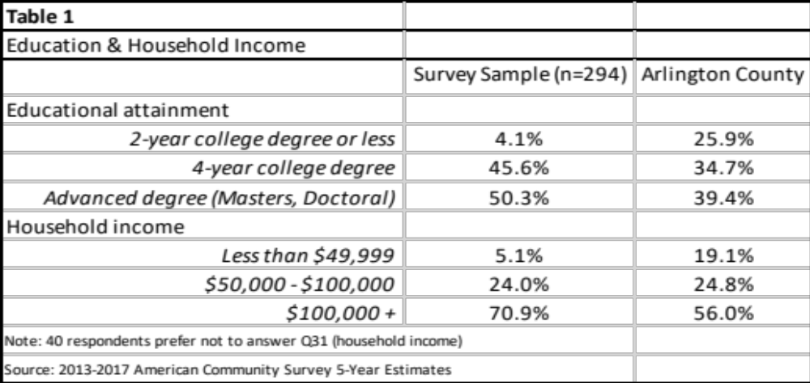

Awareness
Our sample indicates a high overall awareness towards the development and testing of AV technology. Within the prior year, nearly all respondents (96%) indicated that they had read, watched or listened to some media pertaining to the development of AV technology (Table 2).
Actual exposure to AVs was much lower, though; 73% of respondents reported they had neither seen in person nor sat in an AV and did not know anyone who had. As of this writing, there are limited commercial options for AVs available to the public, which likely contributes to this lack of physical exposure. Despite this, there is still sharp interest from our sample in using the technology; 70% of respondents indicated they would consider using AVs if they were available. Respondents indicated that they were more interested in using shared AVs with 47% responding that they would prefer a shared AV while only 28% responded that they would prefer to own or lease one and 44% of respondents said they would be willing to give up an existing private vehicle. However, women were less willing to give up personal cars than men; 51% of men but only 36% of women in the sample said they could imagine giving up an existing private vehicle. A relatively small, but notable group (8%) is largely undecided on whether they would consider using this technology, if available. There are still many unanswered questions about costs and type of vehicles available (shared or personal) which could be contributing to this indecision.

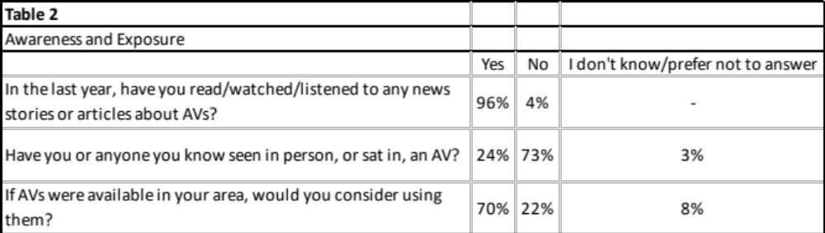

We asked respondents to indicate their perceived knowledge and understanding of the development of AVs. Figure 1 shows the distribution of these responses. Most respondents indicated “I have some knowledge,” with only a handful selecting either “a lot” or “none.” Previous studies have shown that most people report awareness of AV developments and express initial positive opinions of the technology.[] Responses in our survey indicate that there is an opportunity for more education and transparency from the companies developing AVs. For example, the majority of our sample (59%) indicated they would be motivated to learn more about AV development, implying that an increase in the public dissemination of information about the development and testing of AVs would likely lead to greater understanding from the public.

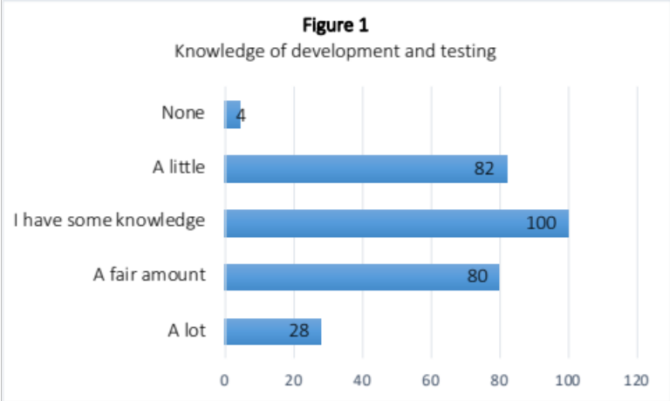

Perceived benefits and concerns
Figure 2 shows the potential benefits of AVs that would be most appealing to our sample. Respondents were allowed to select multiple answers, and thus the total number of responses exceeds our sample size. The top three responses (highlighted in orange) demonstrate that our respondents are most enthusiastic about 1) making better use of their travel time 2) worrying less about finding and paying for parking and 3) reducing overall stress from driving. These selections indicate a desire for more efficient and easy-to-use transportation options.
Heavy traffic congestion may be a contributing factor. The Washington, D.C. region is the third most congested metropolitan area in the country, behind only Los Angeles and San Francisco.[] The relationship between traffic congestion and stress in the U.S. has been thoroughly researched, with strong correlations between high stress levels and gridlock.[] Additionally, high parking costs were the largest overall cost of driving according to one national study in 2017. [] Our results indicate that respondents see AVs as a potential solution to both traffic congestion and high parking costs.
Who in our sample accounted for these results? On average, our sample participants are wealthy, which implies they have high purchasing power. Although it varies by American city, typically families who make more money buy more cars.[] Higher car ownership rates, in turn, can lead to less dependency on public transit.[] It follows that becoming less dependent on public transit and saving money were among the least selected responses in Figure 2.
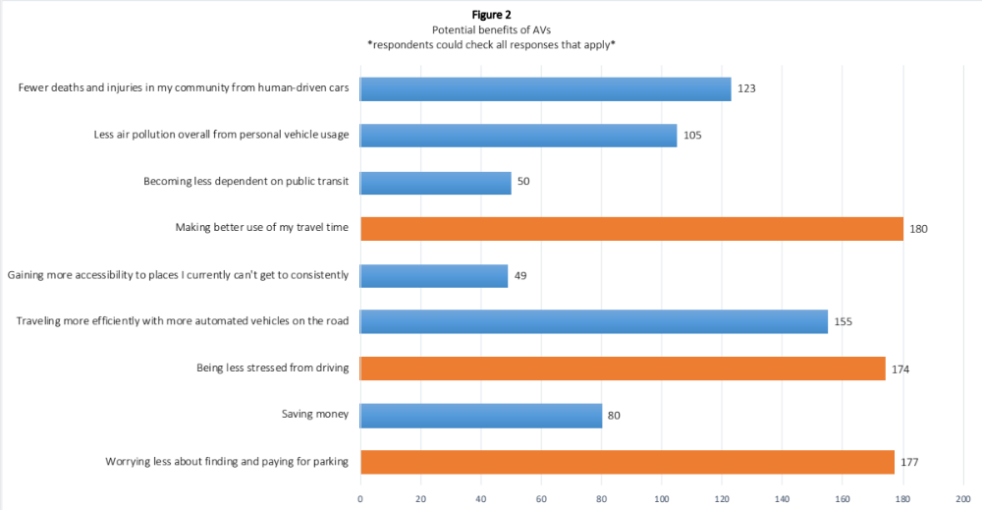

Figure 3 shows the potential risks of AVs that were most concerning for our respondents. Similar to Figure 2, respondents could select multiple choices. Technology not working properly all the time and fears of AVs being hacked were by far the top two selected responses. Concerns with public transit ridership declining was a distant third. As noted, respondents expressed only mild confidence in understanding how AVs are currently being tested and developed (Figure 1).
The transition period to widespread AV usage promises to be challenging in a host of ways. Plus, recent news stories have largely written about testing failures and safety concerns of AVs, emphasizing their vulnerabilities.[7] We find many respondents feel fear and uncertainty around AVs as they exist today. This indicates that transportation and technology companies developing AV technology have work to do to assuage these concerns.
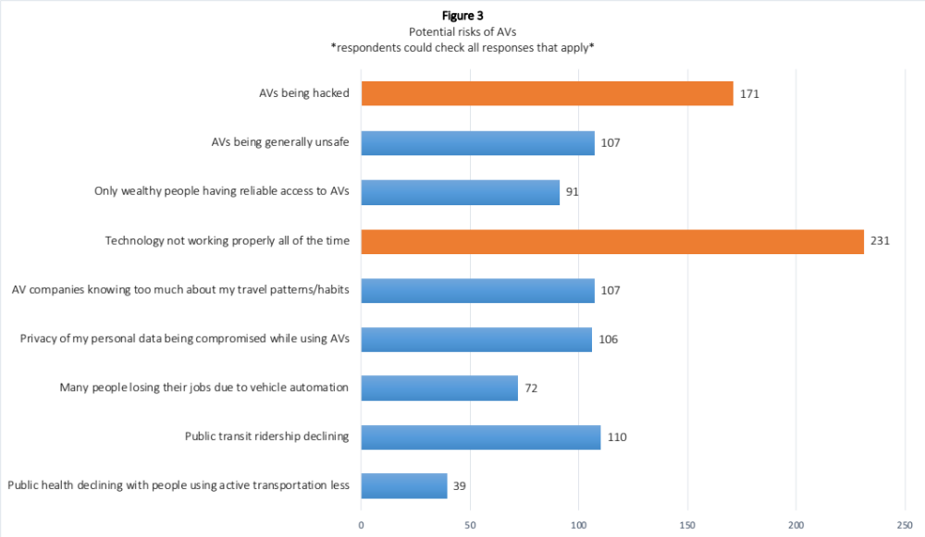

Analysis by gender
We used various statistical tests (t-tests, ANOVA and Chi-squared) to determine whether statistical differences in responses existed by gender. Specific questions were analyzed based on their contribution value to existing literature. The full statistical test results can be found in Appendix B.
Question 4 asked, “How much do you feel you currently know about AV development and testing?” We found that male and female responses were statistically different (at 95% confidence interval) for this question. Men were more likely to indicate they were knowledgeable than women. Exposure to seeing or sitting in AVs (Q5) was the same between men and women. Interestingly, we find that while no differences in exposure to AVs exist, men feel they know more about the development and testing than women.
Within the responses to Q8 (potential benefits), we find differences in selections b) saving money and d) traveling more efficiently with more automated vehicles on the road. Men are almost twice as likely as women to see saving money as a benefit of AVs, although neither gender thinks this is a top potential benefit. The majority of men think that traveling more efficiently will be a benefit of AVs. The opposite is true for women. Choice c) being less stressed from driving, the third most common selection across the entire sample, was chosen by the same percentage of men and women. We can deduce that both men and women see an opportunity for reduced driving stress via AVs adoption.
Within the responses to Q9 (potential risks), we find that selections a) public health declining with people using active transportation less, f) technology not working properly all of the time, and h) AVs being generally unsafe have significant differences between gender. Men are twice as likely to be concerned with public health declining than women, albeit at an overall low frequency. Both genders are quite concerned with technology not working properly all the time, with women more worried about this than men. Similarly, women are more concerned with AVs being generally unsafe than are men. We find similar frequencies from both men and women in their responses to e) AV companies knowing too much about my travel patterns and i) AVs being hacked. This indicates that both genders are equally concerned with these data-sharing and technological vulnerabilities.
Our results from Q10 (How do you feel about AVs in general?) show that there are no differences between men and women. This implies that both men and women feel nearly the same on this question. The mean response for our sample indicates that, on average, respondents feel moderately positive/neutral about AVs. Results from Q24 (How much do you personally enjoy driving?) show that both men and women demonstrate a moderate interest in driving.

Analysis by age
The same statistical tests (t-tests, ANOVA and Chi-squared) were used to determine whether differences in responses existed by the age of respondents. We found no differences between age categories for Q4 and Q10, indicating that age alone does not influence how respondents answered these questions. In Q10 we found that older respondents were more likely to select choice e) strongly negative than younger respondents.
No age differences in Q24 were found, indicating that age alone did not play a role in the response to driving enjoyment. While some research points to older generations enjoying their time driving more than younger generations, our testing does not confirm this.[] Our survey sample is largely young, and youth may have less of a cultural attachment to driving than prior generations.

Summary
Our study contributes a valuable, local perspective on the perceptions and attitudes of people in Arlington County, VA. According to our analysis, respondents have high household income and are highly educated. We found a very high overall awareness of AV testing and development, indicating our sample is largely keeping up with the advancements in this technology. The exposure to AVs, however, has been limited, with most respondents indicating they have had no physical interactions with AVs.
Respondents were most enthusiastic about AVs contributing to more efficient travel, the prospect of less worrying about parking, and reduced stress from driving. Top concerns found were the potential for the technology not to work properly all the time, and vehicle data hacking. These findings confirm prior research indicating that data sharing and data privacy issues should be strong considerations for developers and engineers as the technology continues to advance.
We find key differences in responses by gender, notably how our sample self-reports their own understanding of AV development and testing. Men indicate that they know more about the development and testing of AVs than women, although neither gender says they have had interactive experiences with them. From this we can deduce that men are perhaps more interested in the development than women. Men are almost twice as likely as women to see saving money as a benefit of widespread AV adoption, although neither gender ranks cost-saving as a top potential benefit. Men also think that traveling with greater efficiency will be a benefit, while women report less enthusiasm. Both men and women express interest in reducing driving stress via AV adoption. Contrary to the literature we reviewed, we do not find differences in perception of AVs across age categories.
The ways AV technology will continue to develop is largely in the hands of the transportation and technology companies racing to advance the technology. Our study contributes to the larger body of research on public perception of AVs by offering a local perspective and by showing there is real public interest in their continued development. Understanding local perceptions and attitudes will help inform future efforts to ensure a successful implementation of this technology in Arlington County, VA. Along with the body of evolving literature on this topic, we hope that our research provides planners and policy makers with a snapshot of local perceptions of AVs in 2019.

Recommendations
We recommend involvement of the public in the AV development process, and greater transparency about AV capabilities from the companies building them. Based on our findings, AV developers should focus heavily on improving data privacy protections and reducing vulnerabilities. This has been shown repeatedly to be an important concern of many people who have been surveyed on this topic. At the time of this study, it was apparent that many companies working to develop AVs have not done enough to convince and educate the public about their potential safety benefits. Technology and transportation companies should continue allocating resources dedicated to safety improvements and awareness programs for the public.
Differences in perceptions about AVs between men and women could help AV developers and local governments understand how to best encourage and promote the technology. Further research into why these differences exist should be pursued by all stakeholders. Our study was limited by a relatively small and homogenous sample size and
future studies should sample a more diverse population, more representative of the Washington, D.C. Metro Area as a whole. This research could illuminate important additional findings about AV perceptions across education, race, and income levels.

Appendix A: Survey of Perceptions of Autonomous Vehicles (AVs)
Virginia Tech, in partnership with Arlington County’s Mobility Lab, is conducting a graduate-level urban planning course to study the potential impacts of fully autonomous (self-driving) vehicles (AVs) on Arlington. Recently, transportation and technology companies have been testing fully autonomous cars and shuttles, which are programmed to handle all steering, throttle, and braking (ST&B) decisions based on traffic and road conditions. This survey seeks to provide new, local data to better gauge awareness and attitudes towards these fully autonomous vehicles (hereafter referred to as “AVs”).

The survey is comprised of 5 short sections and should take approximately 10 minutes to complete. Participants who fully complete the survey by March 10th will be eligible for a drawing to win a $50 gift card for select businesses in the Ballston BID. At the conclusion of the survey, you’ll be prompted to voluntarily enter your email address for this drawing. Email addresses will be used solely to contact winners of the drawing, and will not be retained, distributed or used for any other reason. You must be 18 years or older to participate.

(Filtering question) Are you 18 years of age or older?
Yes
No

Responses to this survey are entirely voluntary and any identifiable personal information will remain confidential. By clicking “next,” you are agreeing to participate in this survey.

Part 1 – Introduction

1) Do you live within ½ mile of the Ballston-MU Metro station?
a) Yes
b) No
c) I don’t know/I prefer not to answer

2) Do you work within ½ mile of the Ballston-MU Metro station?
a) Yes
b) No
c) I don’t know/I prefer not to answer

3) In the last year, have you read/watched/listened to any news stories or articles about AVs?
a) Yes
b) No
c) I don’t know/I prefer not to answer

4) How much do you feel you currently know about the development and testing of AVs?
a) A lot
b) A fair amount
c) I have some knowledge
d) A little
e) Nothing
f) I prefer not to answer

5) Have you or anyone you know seen in person, or sat in, an AV?
a) Yes
b) No
c) I don’t know/I prefer not to answer

Part 2 - Perceptions of fully autonomous (self-driving) vehicles (AVs)
For questions 6-14, please consider the potential impact of fully autonomous (self-driving) vehicles (AVs) in the greater Washington, DC region.

6) If AVs were available in your area, would you consider using them?
a) Yes
b) No
c) I don’t know/I prefer not to answer

7) If AVs were introduced today, what would be appealing about them?

8) If AVs were introduced today in your area, what potential benefits would be the most appealing to you? (Check all that apply)
a) Worrying less about finding and paying for parking
b) Saving money
c) Being less stressed from driving
d) Traveling more efficiently with more automated vehicles on the road
e) Gaining more accessibility to places I currently can’t get to consistently
f) Making better use of my travel time
g) Becoming less dependent on public transit
h) Less air pollution overall from personal vehicle usage
i) Fewer deaths and injuries in my community from human-driven cars
j) Other ___________________

9) If AVs were introduced today in your area, what potential risks would concern you the most? (Check all that apply.)
a) Public health declining with people using active transportation less
b) Public transit ridership declining
c) Many people losing their jobs due to vehicle automation
d) Privacy of my personal data being compromised while using AVs
e) AV companies knowing too much about my travel patterns/habits
f) Technology not working properly all of the time
g) Only wealthy people having reliable access to AVs
h) AVs being generally unsafe
i) AVs being hacked
j) Other __________

10) Given the current state of AVs development and your knowledge about them, how do you feel about AVs in general?
a) Strongly positive
b) Moderately positive
c) Neutral
d) Moderately negative
e) Strongly negative
f) I don’t know/I prefer not to answer

11) When commercially available, would you prefer buying or leasing your own personal AVs (like most automobiles today) or would you prefer using a shared AV, similar to a shuttle or ride hailing service (like Uber or Lyft) today?
a) I would prefer to own or lease my own AV
b) I would prefer to use a shared AV
c) I don’t know/I prefer not to answer

12) In the future, could you imagine giving up an existing private vehicle for an on-demand shared-shuttle AV option?
a) Yes
b) No
c) I currently don’t own a vehicle and don’t intend to purchase one
d) I don’t know/I prefer not to answer

13) When do you believe AVs will be commercially available to the general public?
a) Before 2020
b) 2020-2025
c) 2026-2030
d) 2031-2035
e) After 2035

14) Does this survey motivate you to learn more about the potential opportunities and risks of AVs locally?
a) Yes
b) No
c) I don’t know/I prefer not to answer

Part 3 - Commute to work

15) Are you currently employed?
a) Yes
b) No [JUMPS TO PART 4 IF SELECTED]

For questions 16-20, please think about your typical commute to work.

16) Which travel modes do you regularly use to commute to work? (Check all that apply.)
a) Transit Bus
b) Metrorail
c) Personal bike
d) Bike-share
e) Scooter
f) Walk
g) Transportation Network Company (TNCs) such as Uber, Lyft, etc.
h) Taxi
i) Carpooling
j) Vanpool
k) Drive alone
l) Other __________

17) If available, would you consider using an AV for your trip to work?
a) Yes
b) No
c) I don’t know/I prefer not to answer

18) Does your work commute start or end in any of the following jurisdictions? (Check all that apply.)
a) Arlington County, VA
b) District of Columbia
c) City of Alexandria, VA
d) Montgomery County, MD
e) Loudoun County, VA
f) Fairfax County, VA
g) Prince George’s County, MD
h) Other _____________

19) On a typical day, approximately how long does your work commute take?
a) I telecommute
b) More than 1 hour
c) 45 minutes to 1 hour
d) 30 to 45 minutes
e) 15 to 30 minutes
f) Less than 15 minutes
g) I prefer not to answer

20) Do you consistently face any challenges during your typical commute? If so, check all that apply.
a) I usually experience schedule delays on transit
b) I have no viable alternative options
c) Traffic congestion
d) My commute is too expensive
e) Current transit schedules don’t work for me
f) Distance to public transit is too far from where I live
g) Distance to public transit is too far from where I work
h) Ride takes too long
i) I have concerns about my personal safety
j) Inclement or poor weather
k) I have a physical disability that limits my transportation options
l) n/a
m) Other _____________________
n) I don’t know/I prefer not to answer

Part 4 - General travel options
For questions 21-25, please think about your transportation options in general.

21) Which travel modes do you regularly use? (Check all that apply.)
a) Transit Bus
b) Metrorail
c) Personal Bike
d) Bike-share
e) Scooter
f) Walk
g) Transportation Network Company (TNCs) such as Uber, Lyft, etc.
h) Taxi
i) Carpooling
j) Vanpool
k) Drive alone
l) Other __________

22) What factor(s) help determine your primary mode of transportation? (Check all that apply.)
a) Availability of parking
b) Cost of parking
c) Cost of ride
d) Environmental impact
e) Safety
f) Convenience
g) Traffic
h) I don’t have a driver’s license
i) I have a disability that limits my transportation options
j) Other __________________

23) How often do you have a personal vehicle available to you?
a) All the time
b) Most of the time
c) Occasionally
d) Rarely
e) Never

24) How much do you personally enjoy driving?
a) A great deal
b) A moderate amount
c) Not much
d) Not at all
e) I don’t know/I prefer not to answer

25) In an average week, how often do you use ride-sharing or ride-hailing services (Uber, Lyft, etc)?
a) More than 10 times
b) 5-9 times
c) 2-4 times
d) 1 time
e) Never

Part 5 - Demographics
Questions 26-36 ask about yourself. You are free to leave responses blank if you do not wish to share any information.

26) What is your home Zip Code?
a) [ZIP CODE]

27) What is your work Zip Code?
a) [ZIP CODE]

28) What is your gender?
a) Male
b) Female
c) Other
d) I prefer not to answer

29) What is your age?
a) 18 - 24
b) 25 - 34
c) 35 - 44
d) 45 - 54
e) 55 - 64
f) 65 years or older
g) I prefer not to answer

30) What is the highest level of education you have completed?
a) Less than high school
b) High school/GED
c) Some college
d) 2-year college degree
e) 4-year college degree
f) Advanced degree (Masters, Doctoral)
g) I prefer not to answer

31) Approximately what was your total household income last year? (If you live with roommates or other persons who are unrelated to you, please report your individual income.)
a) less than $15,000
b) $15,000 - $24,999
c) $25,000 - $49,999
d) $50,000 - $74,999
e) $75,000 - $99,999
f) $100,000 – $124,999
g) $125,000 - $149,999
h) $150,000 or more
i) I prefer not to answer

32) What sector best describes your current employment?
a) Non-profit
b) Government
c) Private Sector (i.e. Contractor, Hospitality, Food Service, Retail, etc.)
d) Academic
e) Other ________________
f) I am not currently employed
g) I prefer not to answer

33) If you are currently employed, what is your employment status?
a) Employed full-time
b) Employed part-time
c) Student/attending school
d) Retired
e) A homemaker
f) I am not currently employed
g) I prefer not to answer

34) Please select any of the following that applies:
a) I am a business owner
b) I am a member of my local civic association
c) I regularly attend or watch Arlington County Board or Arlington Advisory Group/Commission meetings
d) I occasionally attend or watch Arlington County Board or Arlington Advisory Group/Commission meetings
e) n/a

35) Which categories best describe your race/ethnicity? (You may select multiple options.)
a) White
b) Hispanic, Latino, or Spanish origin
c) Black or African-American
d) Asian
e) American Indian or Alaska Native
f) Middle Eastern or North African
g) Native Hawaiian or other Pacific Islander
h) Other (please specify) _______________________
i) I prefer not to answer

36) Do you own or rent your home?
a) Own
b) Rent
c) Some other arrangement
d) I don’t know/I prefer not to answer

End of Survey

Thank you for your participation in our survey! To show our gratitude to those who completely fill out the survey, we are conducting a drawing to win a $50 gift card for select businesses in the Ballston BID. If you are interested, please enter your email address below_____.
If you have any questions or concerns about this survey, please feel free to reach out to the Virginia Tech research team at selfdrivingcars2019@gmail.com. This research is being overseen by an Institutional Review Board (“IRB”). IRB can be reached at (800) 562 4789, or help@wirb.com, if you have questions or concerns not being answered by the research team.

Thank You!

Appendix B: Statistical analysis in STATA

Gender

Q4 – How much do you feel you know about AVs?
In order to analyze, each ordinal categorical response was coded. Men are coded as Group 1, and women as Group 2. Numerical values were used to value each possible response. (5) was used for “a lot”, value (4) for “a fair amount”, value (3) for “I have some knowledge”, value (2) for “a little”, and value (1) for “nothing”. A two-sample T-test was performed on responses to Q4 by gender. A p-value of .00 was found at a 95% confidence interval.

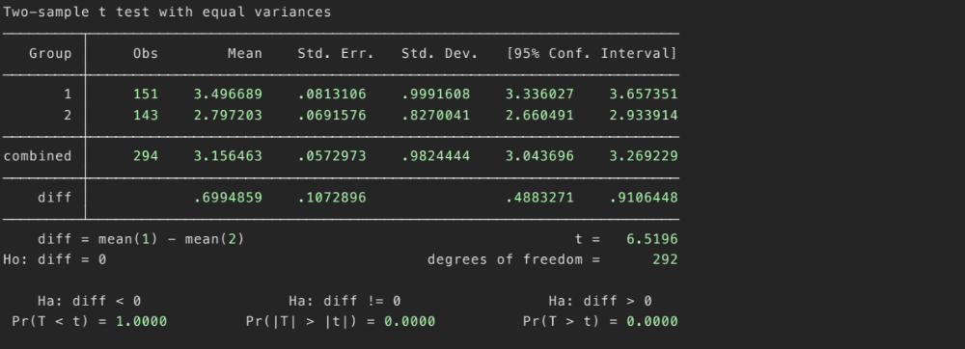

Q5 – Have you seen in person, or sat in an AV?
A Chi-Squared test was performed on responses to Q5 by gender. Men are coded as Group 1, and women as Group 2. (1) was used for “No”, (2) was used for “Yes” and “77” was used to “I don’t know/choose not to answer”. A p-value of .521 was found at a 95% confidence interval.

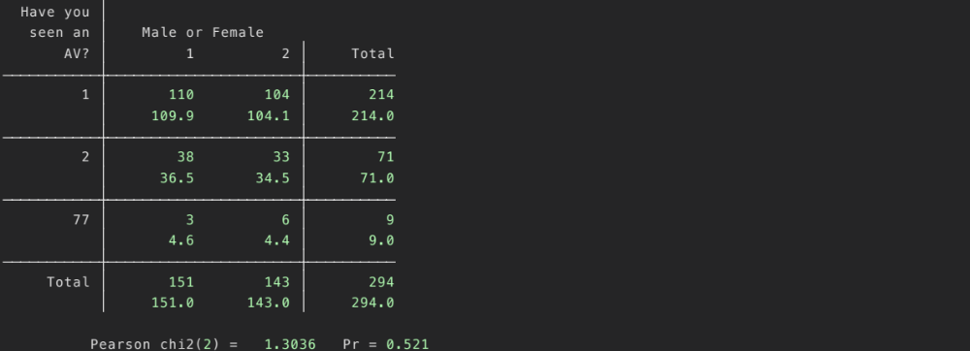

Q8 – Potential benefits
A chi-squared test was used for selection b) saving money. (0) indicates a “No” selection and (1) indicates a “Yes” selection. Men are coded as Group 1, and women as Group 2. A p-value of .002 was found at a 95% confidence interval.


A chi-squared test was used for selection d) traveling more efficiently. (0) indicates a “No” selection and (1) indicates a “Yes” selection. Men are coded as Group 1, and women as Group 2. A p-value of .05 was found at a 95% confidence interval.

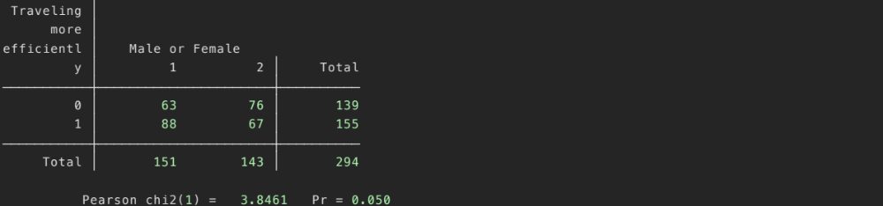

Q9 – Potential Risks
A chi-squared test was used for selection a) public health declining with people using active transportation. (0) indicates a “No” selection and (1) indicates a “Yes” selection. Men are coded as Group 1, and women as Group 2. A p-value of .04 was found at a 95% confidence interval.

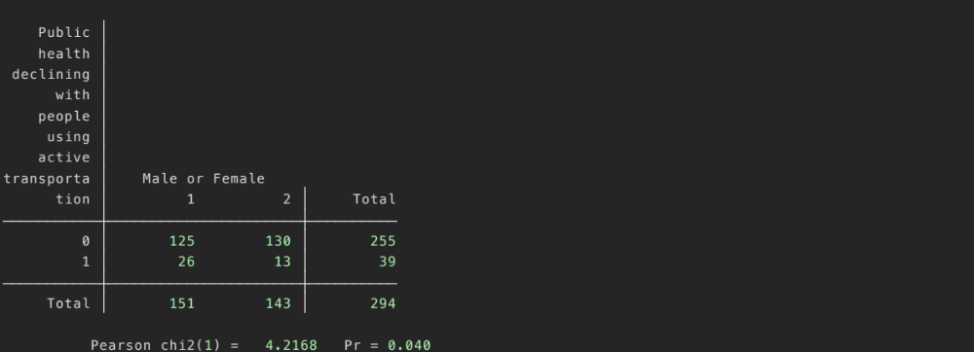

A chi-squared test was used for selection f) technology not working properly all of the time. (0) indicates a “No” selection and (1) indicates a “Yes” selection. Men are coded as Group 1, and women as Group 2. A p-value of .00 was found at a 95% confidence interval.

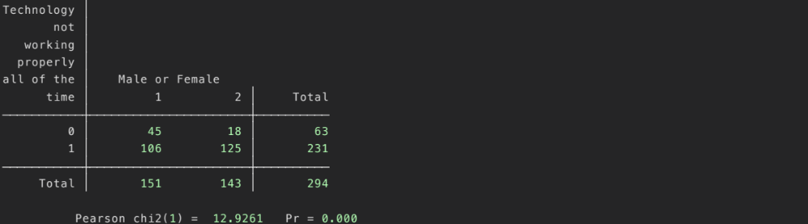

A chi-squared test was used for selection h) AVs being generally unsafe. (0) indicates a “No” selection and (1) indicates a “Yes” selection. Men are coded as Group 1, and women as Group 2. A p-value of .03 was found at a 95% confidence interval.

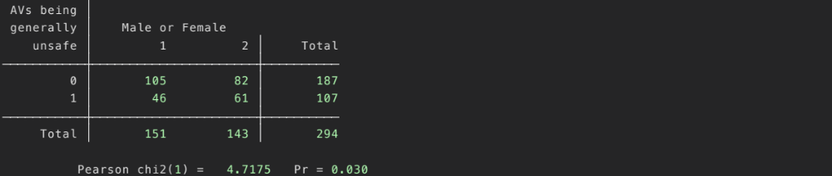

Q10 – How do you feel about AVs in general?
A two-sample T-test was used to test the variance in responses for Q10 by gender. In order to analyze properly, each ordinal categorical response was coded. Numerical value (5) was used for “strongly positive”, value (4) for “moderately positive”, value (3) for “neutral”, value (2) for “moderately negative”, and value (1) for “strongly negative”. Men are coded as Group “1”, women as Group “2”.

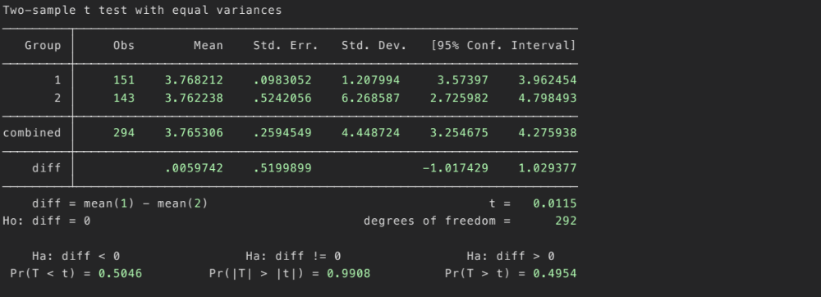

Age

Q4 – How much do you feel you know about AVs?
In order to analyze, each ordinal categorical response was coded. Numerical values were used to value each possible response. (5) was used for “a lot”, value (4) for “a fair amount”, value (3) for “I have some knowledge”, value (2) for “a little”, and value (1) for “nothing”. Age categories were classified as the following: (1) 18-24, (2) 25-34, (3) 35-44, (4) 45-54, (5) 55-64, (6) 65+. A one-way ANOVA was performed on responses to Q4 by age categories.

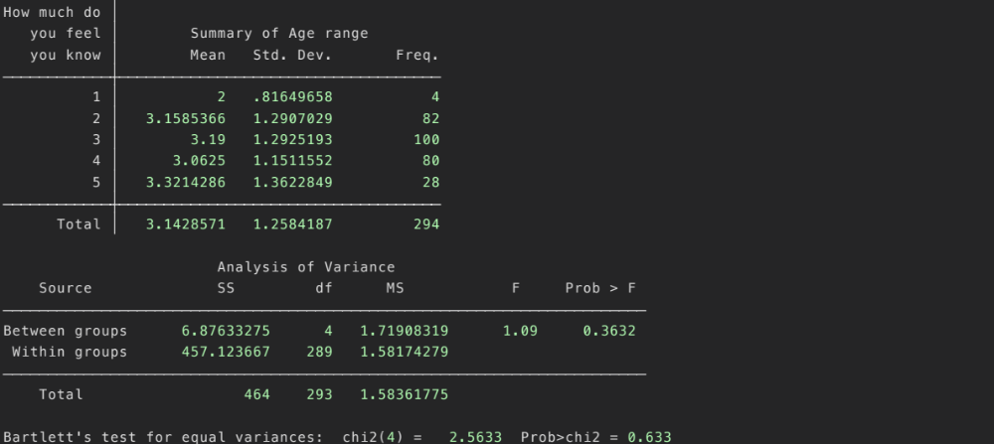

Q10 – How do you feel about AVs in general?
The same one-way ANOVA test was used to test differences in age categories. 5) was used for “a lot”, value (4) for “a fair amount”, value (3) for “I have some knowledge”, value (2) for “a little”, and value (1) for “nothing”. Age categories were classified as the following: (1) 18-24, (2) 25-34, (3) 35-44, (4) 45-54, (5) 55-64, (6) 65+. A one-way ANOVA was performed on responses to Q4 by age categories.
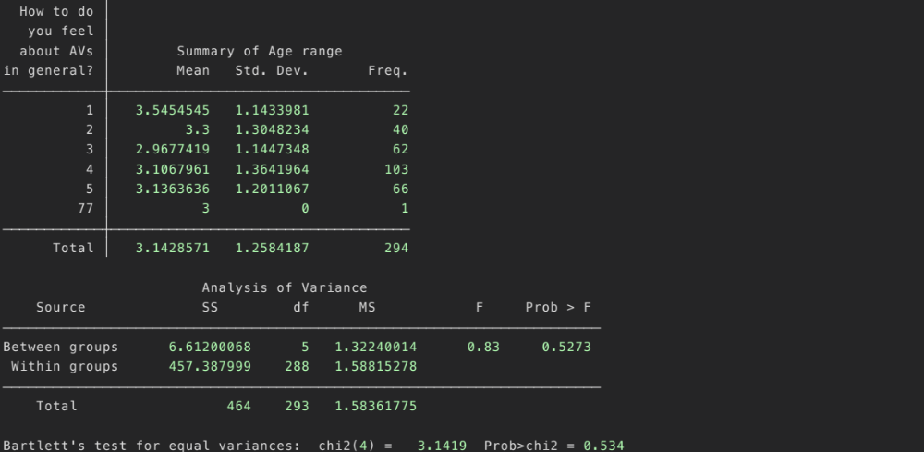

Q24 – How much do you personally enjoy driving?
The same one-way ANOVA test was used to test differences in age categories. 5) was used for “a lot”, value (4) for “a fair amount”, value (3) for “I have some knowledge”, value (2) for “a little”, and value (1) for “nothing”. Age categories were classified as the following: (1) 18-24, (2) 25-34, (3) 35-44, (4) 45-54, (5) 55-64, (6) 65+. A one-way ANOVA was performed on responses to Q4 by age categories.
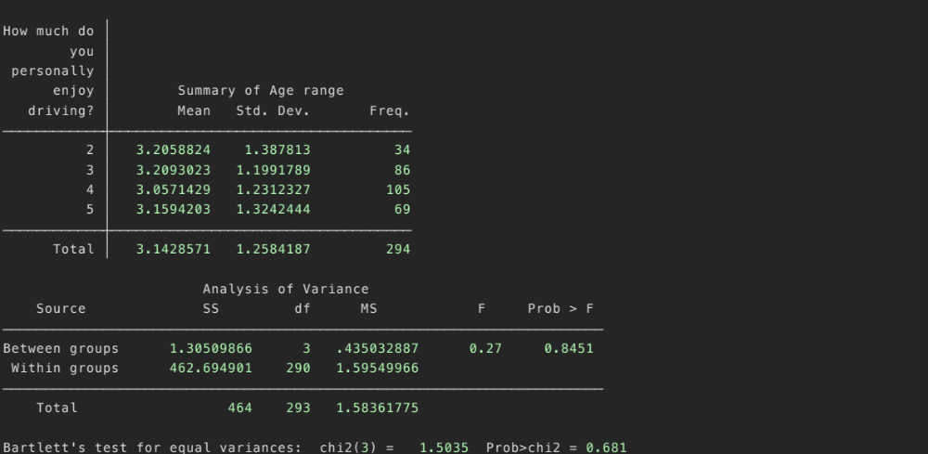

[] Skeete, Jean-Paul. (2018). Level 5 autonomy, the new of disruption in road transport. Retrieved from: https://www.sciencedirect.com/science/article/pii/S0040162517314737
[] Bansal, Prateek; Kockelman, Kara; Singh, Amit. (2016). Assessing public opinions of and interest in new vehicle technologies: An Austin perspective. Retrieved from: https://www.caee.utexas.edu/prof/kockelman/public_html/TRB16NewTechsAustin.pdf
[] ibid
[] Nordhoff, Sina; Winter de, Joost; Kyriakidis, Miltos; et al. (2018). Acceptance of Driverless Vehicles: Results from a Large Cross-National Questionnaire Study. Retrieved from: https://www.researchgate.net/publication/323907099_Acceptance_of_Driverless_Vehicles_Results_from_a_Large_Cross-National_Questionnaire_Study
[] Reimer, Bryan. (2014). Driver Assistance Systems and the Transition to Automated Vehicles: A Path to Increase Older Adult Safety and Mobility? Retrieved from: https://www.researchgate.net/publication/270441446_Driver_Assistance_Systems_and_the_Transition_to_Automated_Vehicles_A_Path_to_Increase_Older_Adult_Safety_and_Mobility
[] Fagnant, Daniel; Kockelman, Kara. (2016). Dynamic ride-sharing and fleet sizing for a system of shared autonomous vehicles in Austin, Texas. Retrieved from: https://www.caee.utexas.edu/prof/kockelman/public_html/TRB15SAVswithDRSinAustin.pdf
[] Crute, Jeremy; Riggs, William; Chapin, Timothy; Stevens, Lindsay. (2018). Planning for Autonomous Mobility. Retrieved from: https://www.planning.org/publications/report/9157605/
[] Reimer, Bryan. (n 5).
[] Gonzales, Richard. (2019). Feds Say Self-Driving Uber SUV Did Not Recognize Jaywalking Pedestrian In Fatal Crash. Retrieved from: https://www.npr.org/2019/11/07/777438412/feds-say-self-driving-uber-suv-did-not-recognize-jaywalking-pedestrian-in-fatal-
[] Kyriakidis, M; Happee, R; de Winter, JCF. (2015). Public opinion on automated driving: Results of an international questionnaire among 5,000 respondents. Retrieved from: https://www.sciencedirect.com/science/article/abs/pii/S1369847815000777
[] Bansal, Prateek. (n 2).
[] “Mobility Lab is a research center and news source for transportation behavior and policy. It is based in Arlington, Virginia - which has one of the largest "transportation demand management" programs in the U.S., removing 45,000 car trips from the county's roads each work day. We do original research about Arlington’s TDM efforts and communicate best practices worldwide.” Retrieved from: https://mobilitylab.org/what-is-mobility-lab/
[] Moody, Joanna; Bailey, Nathaniel; Zhao, Jinhua. (2020). Public perceptions of autonomous vehicle safety: An international comparison. Retrieved from: https://www.sciencedirect.com/science/article/pii/S0925753518315285
[] Nielson, Thomas Alexander; Haustein, Sonja. (2018). On sceptics and enthusiasts: What are the expectations towards self-driving cars? Retrieved from: https://www.researchgate.net/publication/326742996_On_sceptics_and_enthusiasts_What_are_the_expectations_towards_self-driving_cars
[] Nordhoff, Sina. (n 4).
[] Kyriakidis, M. (n 10).
[] Schoettle, Brandon; Sivak, Michael. (2014). A survey of public opinion about autonomous and self-driving vehicles in the U.S., the U.K., and Australia. Retrieved from: https://deepblue.lib.umich.edu/handle/2027.42/108384
[] Bansal, Prateek. (n 2).
[] Kyriakidis, M. (n 10).
[] Regan, Michael; Horberry, T; Stevens, A. (2014). Driver acceptance of new technology: Theory, measurement and optimization. Retrieved from: https://www.researchgate.net/publication/295598098_Driver_acceptance_of_new_technology_Theory_measurement_and_optimisation
[] Crute, Jeremy. (n 7).
[] Howard, Daniel; Dai, Danielle. (2013). Public Perceptions of Self-driving Cars: The Case of Berkeley, California. Retrieved from: https://www.ocf.berkeley.edu/~djhoward/reports/Report%20-%20Public%20Perceptions%20of%20Self%20Driving%20Cars.pdf
[] RAC. (2018). Automated vehicles: Community perceptions monitor. Retrieved from: https://www-cdn.rac.com.au/-/media/files/rac-website/about-rac/media/2018/automated-vehicles----community-perceptions-monitor.pdf?la=en&modified=20181029092909&hash=B6C17B5A578976B7BD2323FEB1E36FCB62CC688C
[] Bansal, Prateek. (n 2).
[] Nordhoff, Sina. (n 4).
[] Kyriakidis, M. (n 10).
[] Kyriakidis, M. (n 10).
[] Kyriakidis, M. (n 10).
[] Kyriakidis, M. (n 10).
[] Schoettle, Brandon. (n 17).
[] Bansal, Prateek. (n 2).
[] Nordhoff, Sina. (n 4).
[] Kyriakidis, M. (n 10).
[] Krueger, Rico; Rashidi, Taha H; Rose, John M. (2016). Preferences for shared autonomous vehicles. Retrieved from: https://trid.trb.org/view/1417516
[] Hohenberger, Christoph; Sporrle, Matthias; Welpe, Isabell. (2016). How and why do men and women differ in their willingness to use automated cars? The influence of emotions across different age groups. Retrieved from: https://www.sciencedirect.com/science/article/abs/pii/S0965856415301464
[] Payre, William; Cestac, Julien; Delhomme, Patricia. (2014). Intention to use a fully automated car: Attitudes and a priori acceptability. Retrieved from: https://www.sciencedirect.com/science/article/abs/pii/S1369847814000473
[] Howard, Daniel. (n 22).
[] Havlickova, Darina; Gabrhel, Vit; Adamovska, Eva; Zamecnik, Petr. (2020). The role of gender and age in autonomous mobility: general attitude, awareness and media preference in the context of Czech Republic. Retrieved from: https://www.researchgate.net/publication/338657677_The_role_of_gender_and_age_in_autonomous_mobility_general_attitude_awareness_and_media_preference_in_the_context_of_Czech_Republic
[] Anania, Emily C; Rice, Stephen; Walters, Nathan W; Pierce, Matthew; et al. (2018). The effects of positive and negative information on consumers’ willingness to ride in a driverless vehicle. Retrieved from: https://www.sciencedirect.com/science/article/abs/pii/S0967070X17305450
[] Garsten, Ed. (2018). Sharp Growth In Autonomous Car Market Value Predicted But May Be Stalled By Rise In Consumer Fear. Retrieved from: https://www.forbes.com/sites/edgarsten/2018/08/13/sharp-growth-in-autonomous-car-market-value-predicted-but-may-be-stalled-by-rise-in-consumer-fear/#1ac30d47617c
[] Kyriakidis, M. (n 10).
[] Nielson, Thomas Alexander. (n 14).
[] Kyriakidis, M. (n 10).
[] Schoettle, Brandon. (n 17).
[] Nielson, Thomas Alexander. (n 14).
[] Schoettle, Brandon. (n 17).
[] Havlickova, Darina. (n 38).
[] Hohenberger, Christoph. (n 35).
[] Czaja, Sara J; Fisk, Arthur D; Hertzog, Christopher; et al. Factors Predicting the Use of Technology: Findings From the Center for Research and Education on Aging and Technology Enhancement (CREATE). Retrieved from: https://www.ncbi.nlm.nih.gov/pmc/articles/PMC1524856/
[] Hulse, Lynn; Xie, Hui; Galea, E.R. (2018). Perceptions of autonomous vehicles: Relationships with road users, risk, gender and age. Retrieved from: https://www.researchgate.net/publication/322863285_Perceptions_of_autonomous_vehicles_Relationships_with_road_users_risk_gender_and_age
[] Havlickova, Darina. (n 38).
[] Nordhoff, Sina. (n 4).
[] Bansal, Prateek. (n 2).
[] Payre, William. (n 36).
[] Pyrialakou, Dimitra V; Gkartzonikas, Christos; Gatlin, Drew J; Gkritza, Konstantina. (2020). Perceptions of safety on a shared road: Driving, cycling, or walking near an autonomous vehicle. Retrieved from: https://www.researchgate.net/publication/338605970_Perceptions_of_safety_on_a_shared_road_Driving_cycling_or_walking_near_an_autonomous_vehicle
[] Havlickova, Darina. (n 38).
[] Arlington County, Virginia. (2019). Department of Community Planning, Housing, and Development: Profile 2019. Retrieved from: https://arlingtonva.s3.amazonaws.com/wp-content/uploads/sites/31/2019/05/Profile2019_5_10_19_FINAL.pdf
[] Schoettle, Brandon. (n 17).
[] Belt, Deb. (2019). Here's How Washington, DC Ranks For Traffic Congestion. Retrieved from: https://patch.com/district-columbia/washingtondc/here-s-how-washington-dc-ranks-traffic-congestion
[] Frakt, Austin. (2019). Stuck and Stressed: The Health Costs of Traffic. Retrieved from: https://www.nytimes.com/2019/01/21/upshot/stuck-and-stressed-the-health-costs-of-traffic.html
[] Wylie, Melissa. (2018). The cost of parking may surprise you. Retrieved from: https://www.bizjournals.com/bizwomen/news/latest-news/2018/04/the-cost-of-parking-may-surprise-you.html?page=all
[] Grabar, Henry. (2019). Where Rich People Don’t Own Cars. Retrieved from: https://slate.com/business/2019/05/maps-car-ownership-income-population-density-green-new-deal.html
[] Manville, Michael; Taylor, Brian; Blumenberg, Evelyn. (2018). Falling Transit Ridership: California and Southern California. Retrieved from: https://www.its.ucla.edu/2018/01/31/new-report-its-scholars-on-the-cause-of-californias-falling-transit-ridership/
[] Wisniewski, Mary. (2018). Why Americans, particularly millennials, have fallen out of love with cars. Retrieved from: https://www.chicagotribune.com/business/ct-biz-young-adults-cars-attitudes-20181106-story.html

